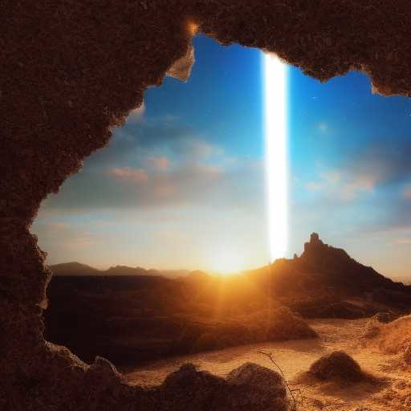
THE MYSTERIES OF HOD v.1

May the mysteries of הוֹד be revealed to the just
May the Immortal Sparks come alive as new stars
May Truth ascend through splendorous realms
May the שְׁכִינָה be to us as a Blessed Assurance
May we take to ourselves the Righteous Soul, within us & others
May Shiva’s dance of stillness be upon us through כֶּתֶר

